**Problem:1 Solution Cylindrical Bearings Classification**

**Solution folder overview:**

**1.** The solution can be found from the following link in google drive.

[**https://drive.google.com/drive/u/0/folders/1u7escWsKvI_Pp66e5tcPkcjFLZNmd-Ny**](https://drive.google.com/drive/u/0/folders/1u7escWsKvI_Pp66e5tcPkcjFLZNmd-Ny)

**2.** The link contains following folders

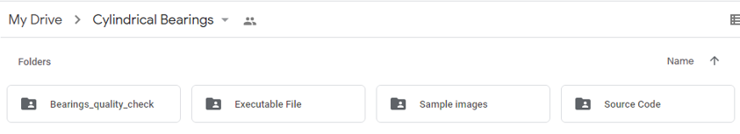

**a. Bearing_quality_check:** This contains all the files needed to build the exe, and windows application.

**b. Executable File:** This contains the **Bearings_classifier.exe** file that was built from source code using **Pyinstaller library**

**c. Sample images:** This contains sample images delivered during the assignment(Contains two folders corresponding to Good and Bad bearings images)

**d. Source code:** The folder contains following files

1. Bearings_classifier.py: Contains the python code for building interactive GUI for Bearing classification based on input image queried in the form of a folder, which contains the images.

2. Bearings.py: Contains the python class which contains the functionality for Bearing detection in images, and needle counts in the bearings, and which in turn helps to classify the bearings(If needle count=16 Good elsse Bad bearing)

**Dependencies and Libraries:**

* **matplotlib.pyplot:** Used to handle images and visualization.
* **OS:** Used to handles files from directories and folder operations
* **Cv2:** Opencv library used to handle images, implementing circle detection algorithm named **HoughCircles**
* **Numpy:** Used to perform numerical operations
* **PySimpleGUI:** Used to build interactive GUI for testing of bearings quality.

**Execution:**

**To execute the solution don’t need to install any dependencies or no further setup needed to run,** simply click the executable file(Bearings_classifier.exe), and follow the steps mentions in next page. The file is executable in windows, if want I can also build windows app to install it for further testing.

**Steps for execution:**

**1.** Go to the following drive link(Edit permission is given) [**https://drive.google.com/drive/u/0/folders/1u7escWsKvI_Pp66e5tcPkcjFLZNmd-Ny**](https://drive.google.com/drive/u/0/folders/1u7escWsKvI_Pp66e5tcPkcjFLZNmd-Ny)

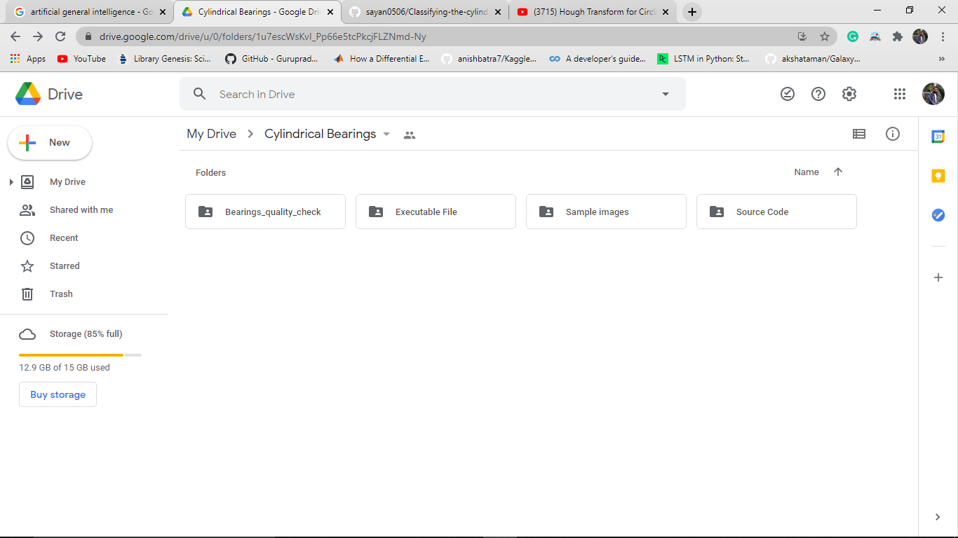

**2.** Go to the folder named **Executable File**(Marked below) to get the .exe file.

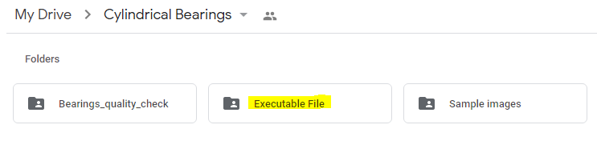

**3.** Download the following **Executable File(.exe)** named **Bearings_classifier.exe**

**Note: It is better to disable antivirus, else it may delete the file while downloading**

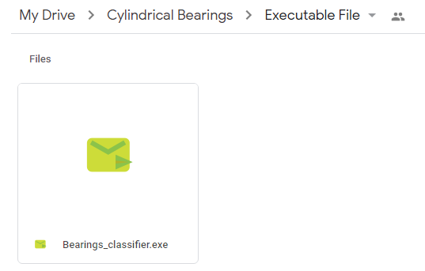

**4.** Then to execute right click on **.exe 🡪Open**

**Note:**

* **The file is a bit slow to open, and it may take few minutes to open from step 4 to 5, and after opening the GUI it will work smoothly.**
* **The file may be deleted during the execution so allow the file to execute from the antivirus before execution.**

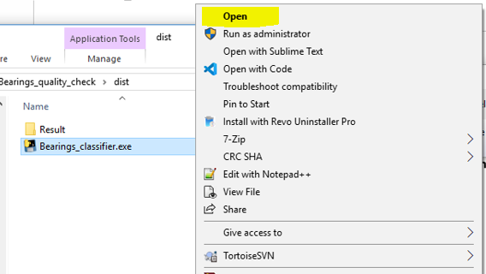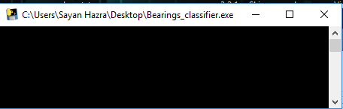

**5.** After few time the GUI will opened automatically named **Roller Bearings Quality Check.**

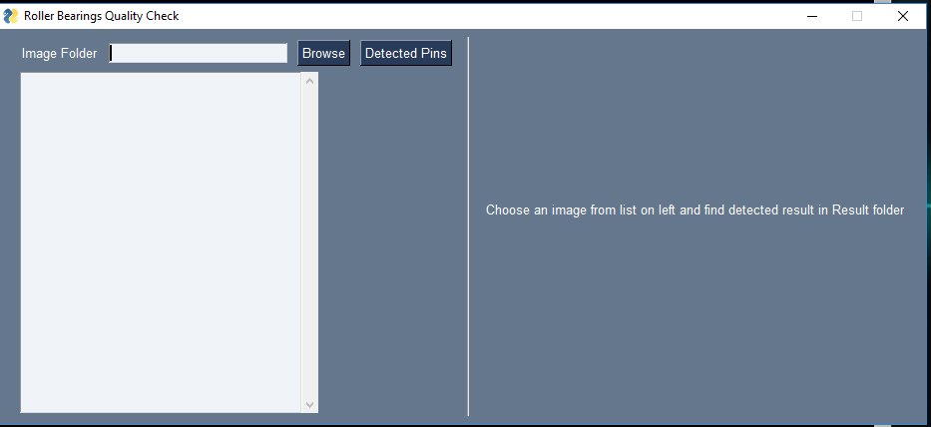

**6.** Enter or browse the image folder, and select it.

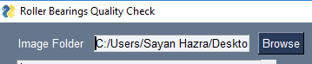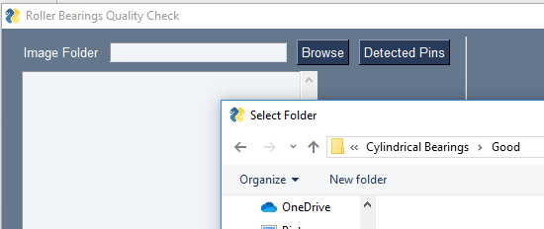

**7.** Select the image from the list, which corresponds to the folder.

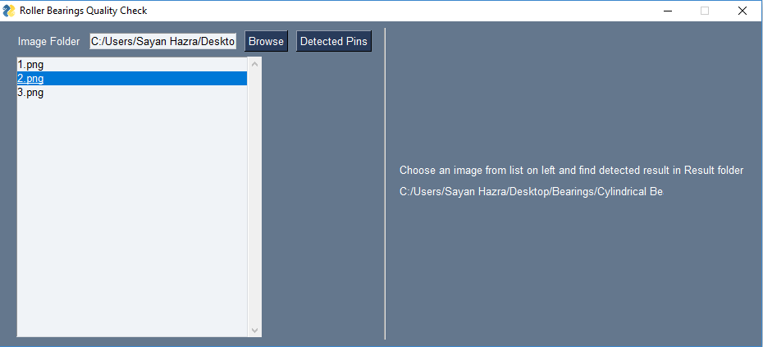

**8.** Click on **Detected Pins** button to find the pin count in the bearings and visualize pins with overlay. **The detected results will be stored in ‘Result’ folder** **created automatically on 1st selection.**

**Example 1**: A Good bearing is detected with 16 needles count and needles are visible here.

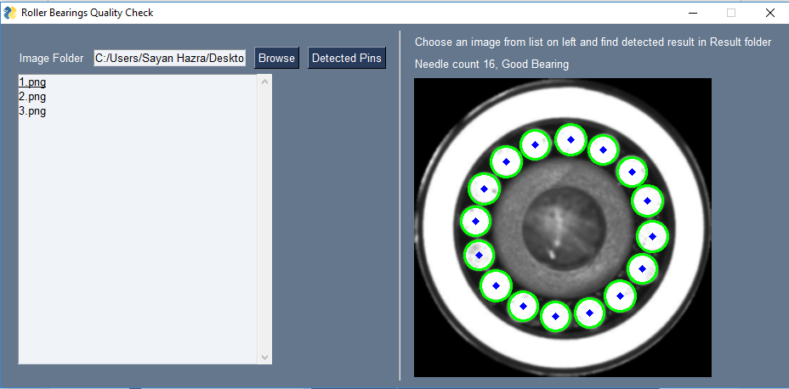

**Example 2:** A Bad bearing is detected with 15 needles count and needles are visible here.

